Robert Kristian Alm
Movant 19/03/2017

6a (VLANs and Trunks for Beginners - Part 1)

The link of the video: https://www.youtube.com/watch?v=aBOzFa6ioLw

On this assignment The instructions was about creating at least one VLAN with a custom name, and overview on how can someone configure things on a switch through a CLI, (Command Line Interace).

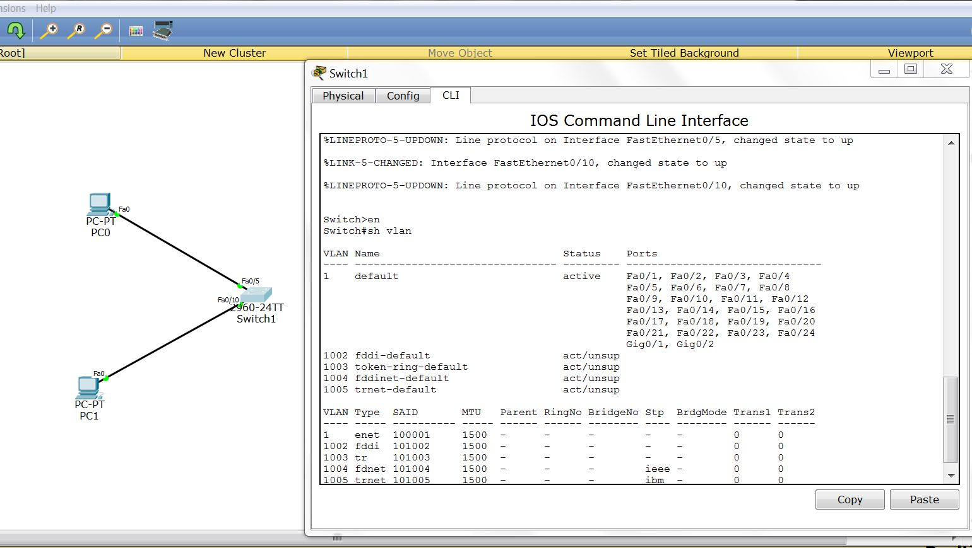

The initial hardware configuration was two generic PCs with the following IP addresses 192.168.1.100 and 192.168.1.101 and a Switch 1960-24TT between them. The instructions asked us to connect the one PC on port 5 of the Switch and the other one on port 10.
We did a successful ping to check that everything was working properly.

The next step was through the CLI of the switch witch by using CLI commands we checked the configuration of the switch. Every router has always as default VLAN 1 in witch every port is assigned as default. There are as well four VLANs, (from 1002 to 1005), that are serving a specific technical reason, (for example Backward compatibility etc). Those VLAN's and the VLAN1 can't be removed from the configurations.

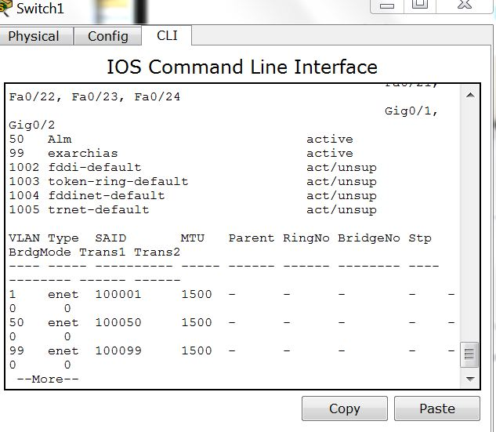

The important thing about part 1 is the coverage of the command lines that we used:

sh vlan: It shows the configuration of the switch.
show running-config: it shows that as well in a different way
config t: it opens the shell on the CLI that will allow as to configure the terminal, (the machine = the switch in our case).
vlan <NUMBER>: it is creates/opens a VLAN with the desired number, (for example vlan 50)
?: it gives informations about the available options. In our case the available options of the chosen VLAN, (for example name, access, exit)
name: it gives a name to the entity, (the choose VLAN in our case)
exit: it takes us from the config t – shell to the main CLI.

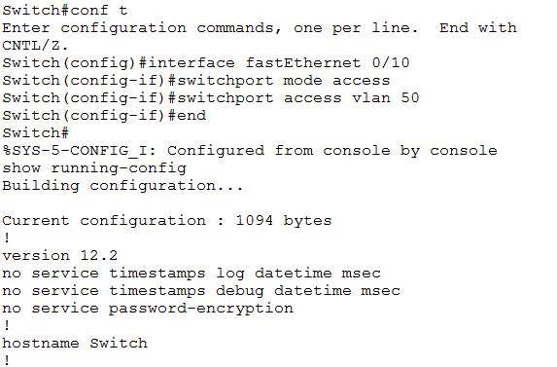

The last part was to assign a port to the VLAN that we created. For that we had to go back on config t shell and choose the desired port interface, (the number 10 in our case):

interface fastEthernet 0/10: connects to the interface of port 10
switchport mode access: It activates the access to the port.
switchport access vlan 50: gives vlan 50 access to the port 10, (0/10 actually).
end: ends the session on the config t of the selected entity, (the interface of port 10 in our case).

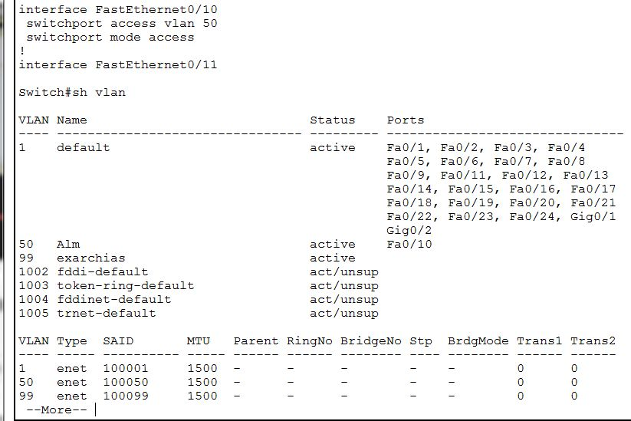

In the very end of the video. The speaker explains that a computer that belongs to a VLAN can't access a computer of another VLAN. We tried unsuccessfully the initial ping, so it was clear that it was not possible for on pc of one VLAN to communicate with a computer of another VLAN unless we have a router or if the switch is layer 3 switch.

